|  |  |
| --- | --- |
|  | **2015** |
|  | One Team Project  LinhTT |

|  |
| --- |
| **[Use Case Diagrams]** |
| Use Case Diagrams |

Contents

1. Registration (in client) 4

2. Using System (in client) 5

3. Shutdown Options 6

1. Registration (in client)

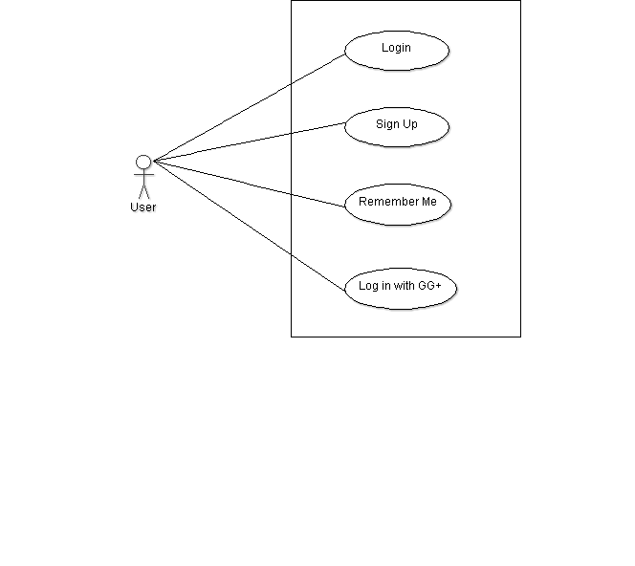

1. Using System (in client)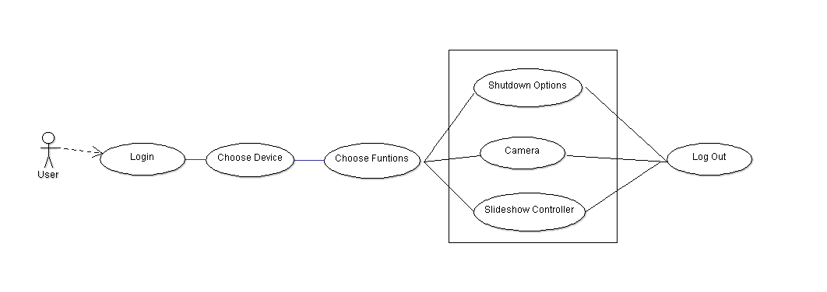
2. Shutdown Options